ClassAssignment1 Report

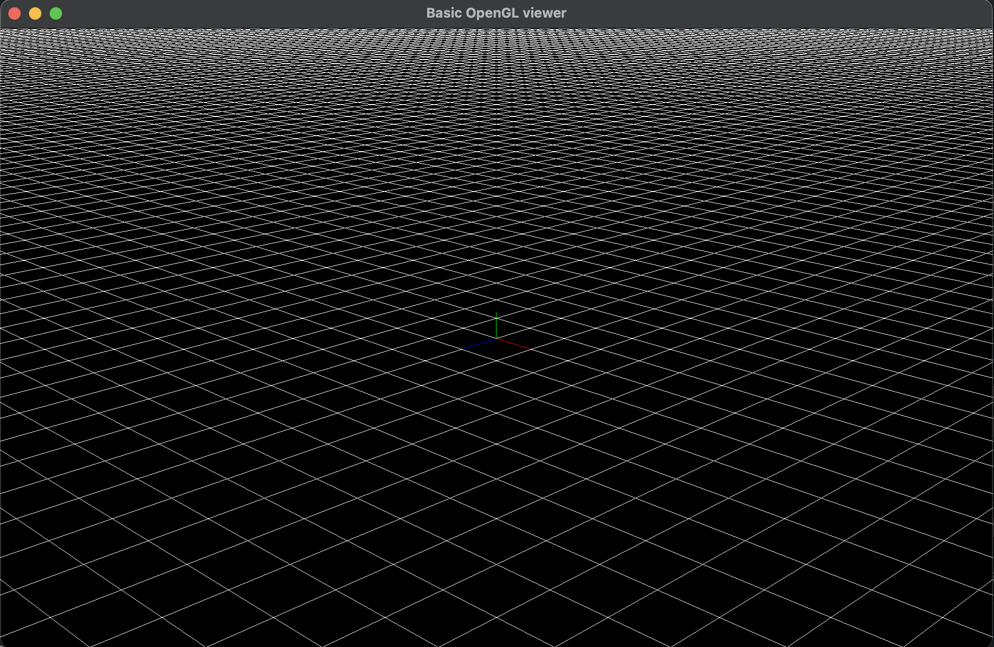

Perspective Projection

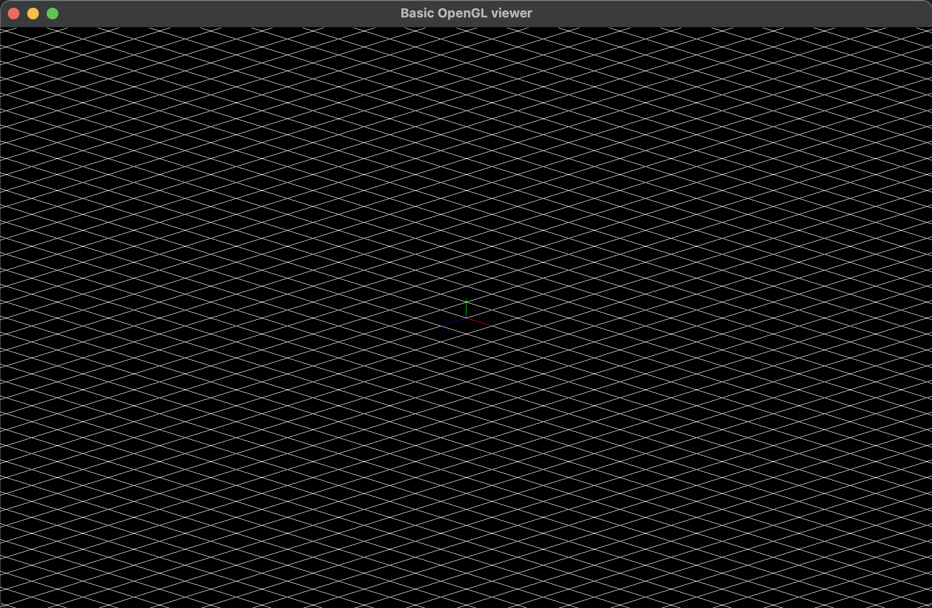

Orthogonal Projection

**2016025041** 하태성

* **Toogle Projection** 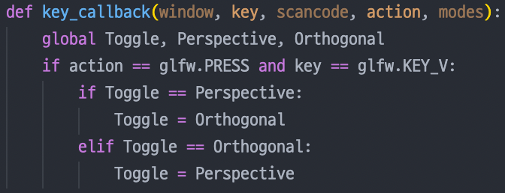by pressing ‘v’ key

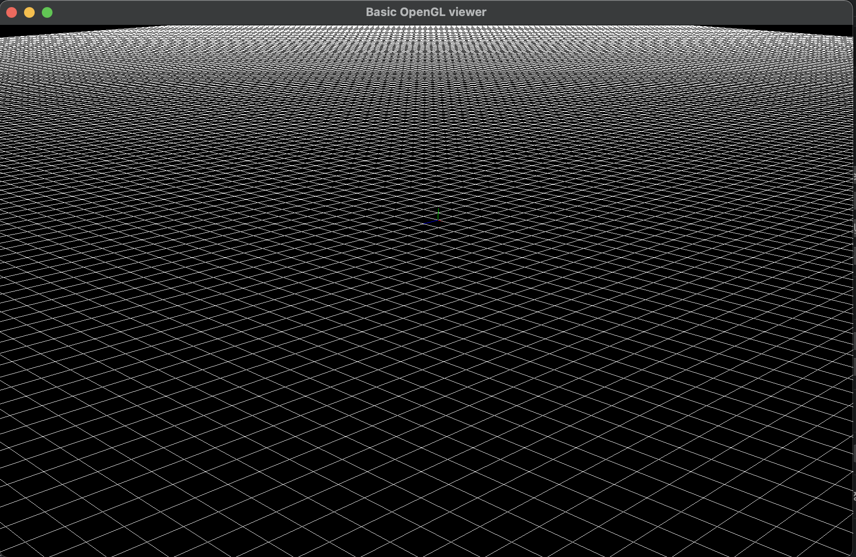

Rectangular Grid

* **Draw Rectangular Grid** on xz plane

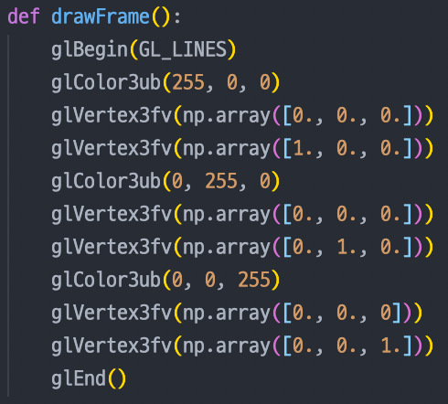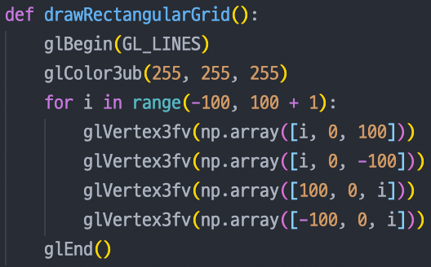

* **Zoom** : Move the camera forward toward the target point (zoom in) and backward 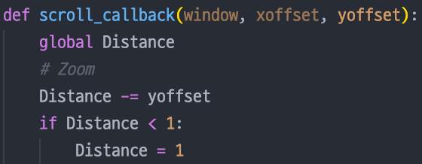away from the target point(Rotate mouse wheel)

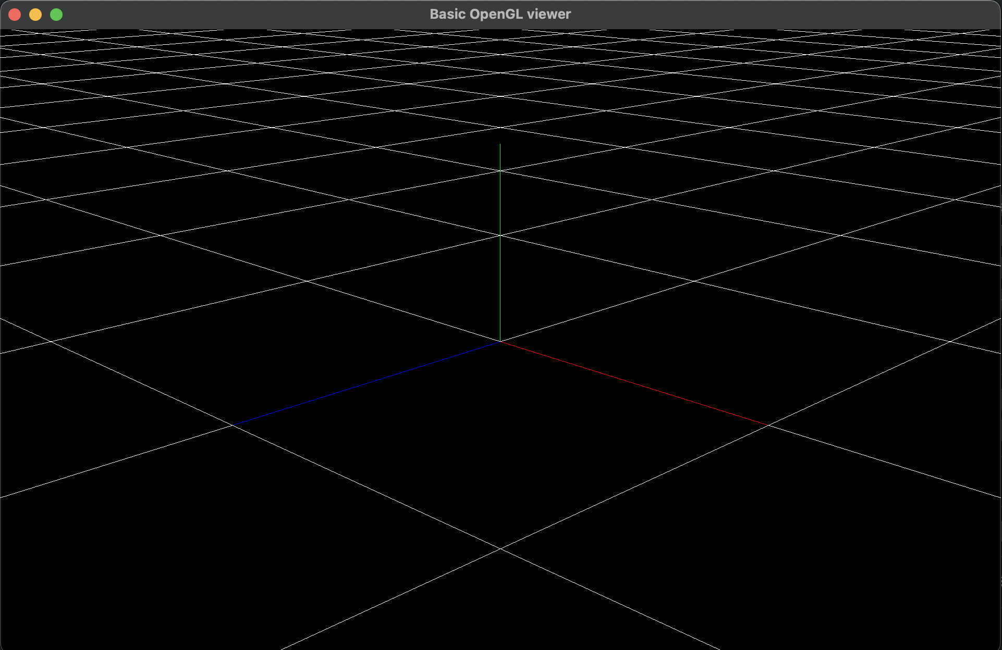

Zoom

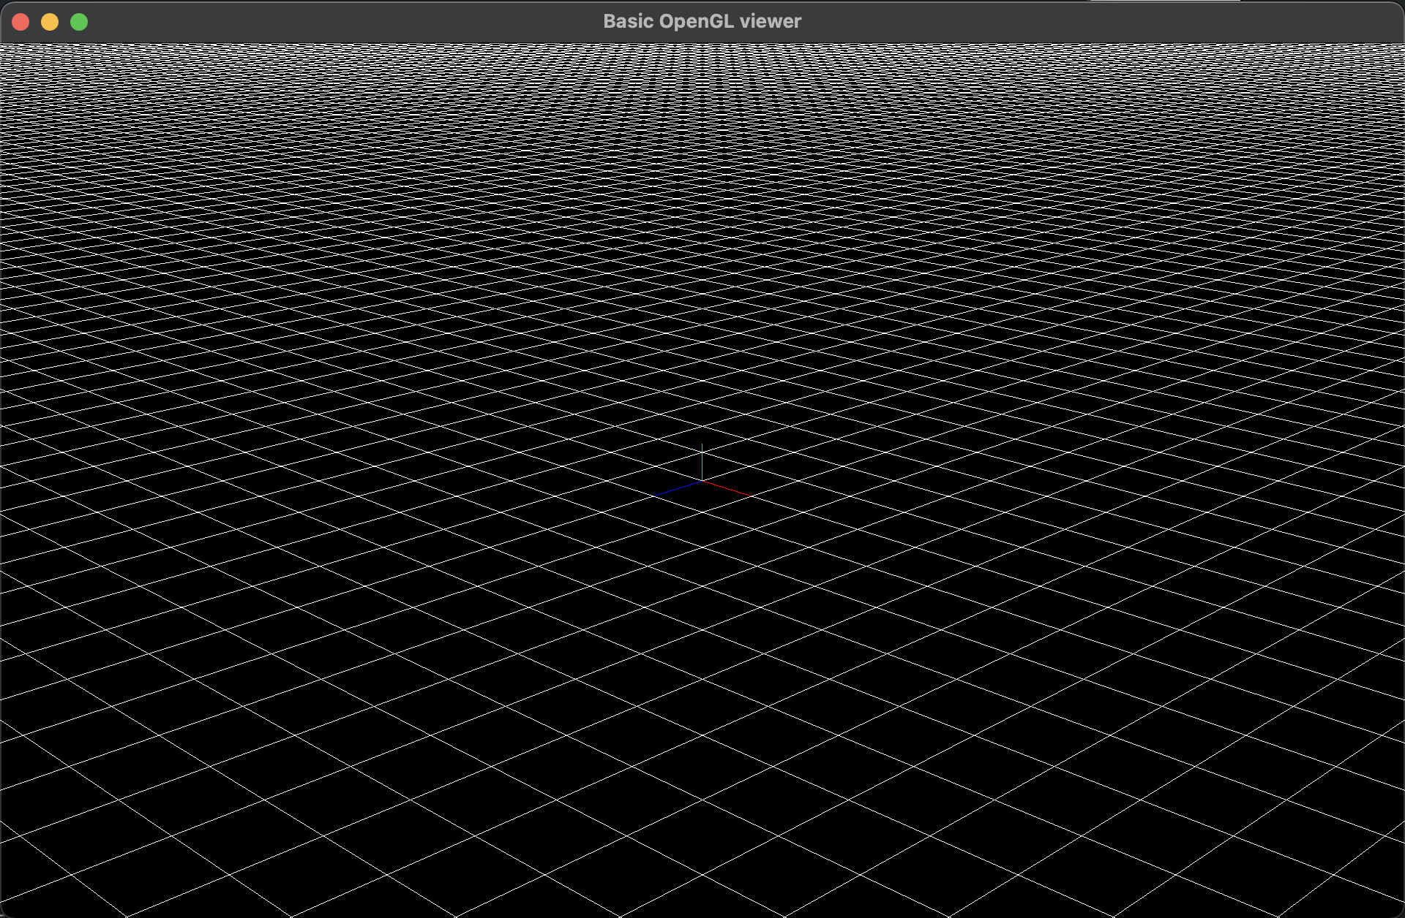

Original

* **Orbit** : Rotate the camera around the target point by changing azimuth / elevation angles(Click mouse left button & drag)
* **Pan** : Move both the target point and camera in left, right, up and down direction of the camera(Click mouse right button & drag)

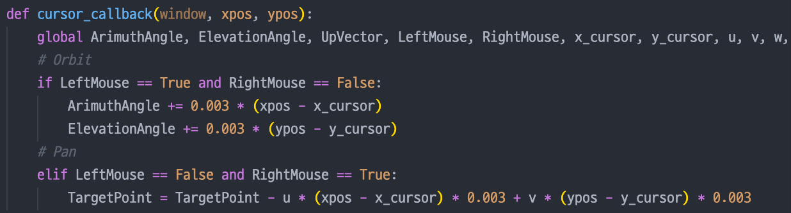

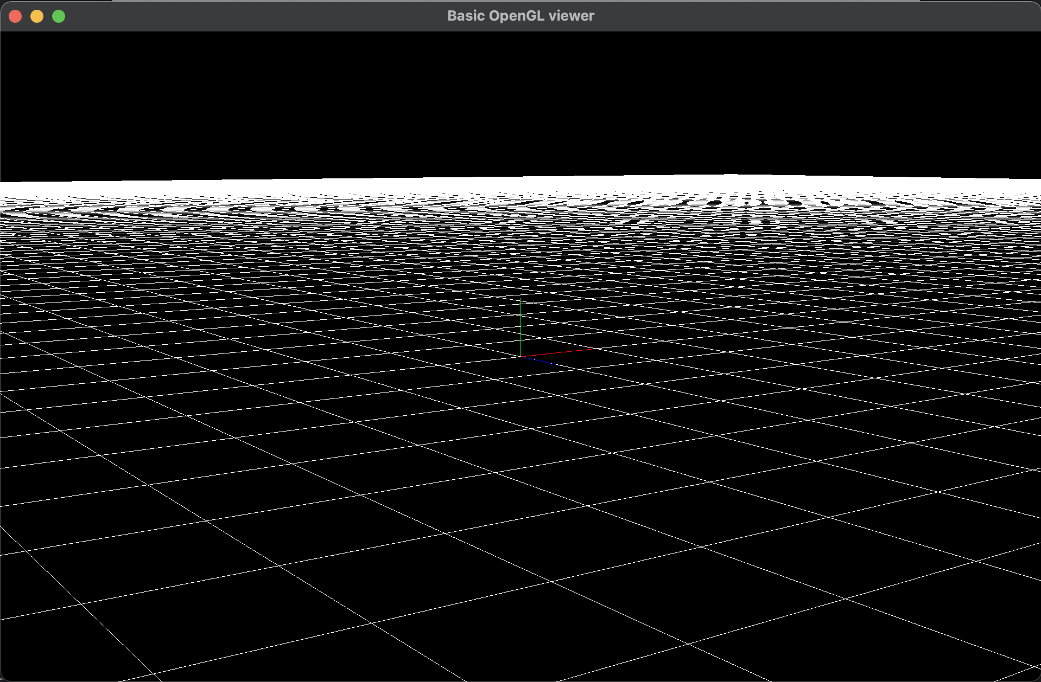

Orbit

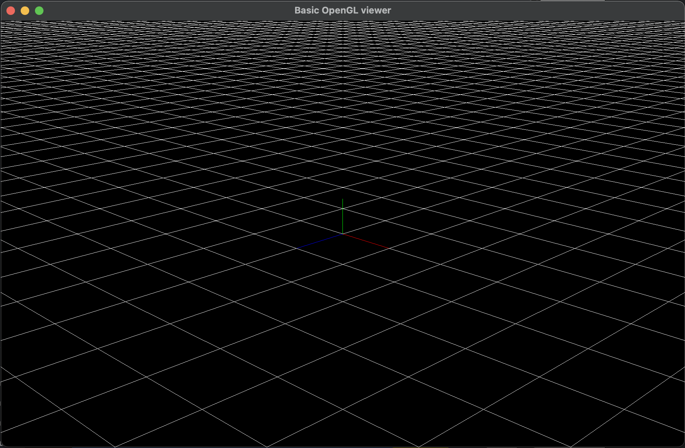

Original

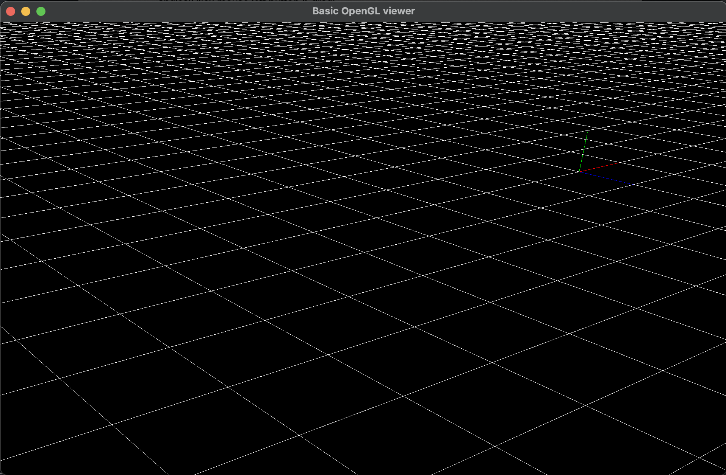

Pan

- Render Function : Choose Projection and Calculate Camera’s coordinate(Eyepoint) and 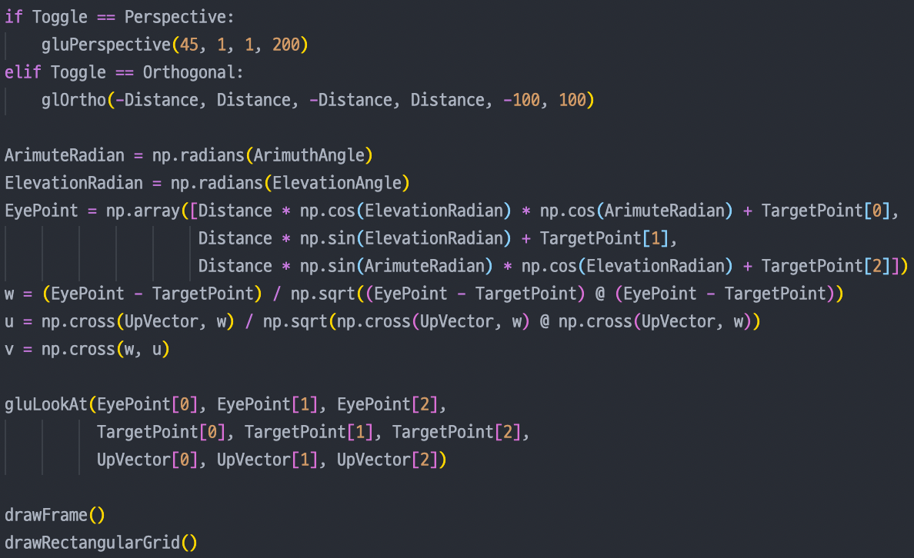vectors(u, v, w). Then Set Camera, Draw Frame and Grid.